1. Create a new GitHub repository.
- Clone the repository to your local machine using SSH (generate an SSH key if needed, add the public key to your GitHub account).
- Create a new branch named after your username (e.g., sunita).
- Add your Flask project files to this branch.
Commit the changes and merge the branch into the main branch.

Private Repository created.
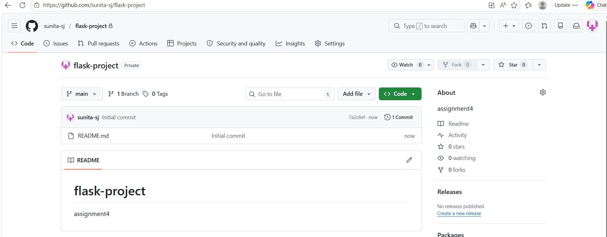
SSH key already mapped.
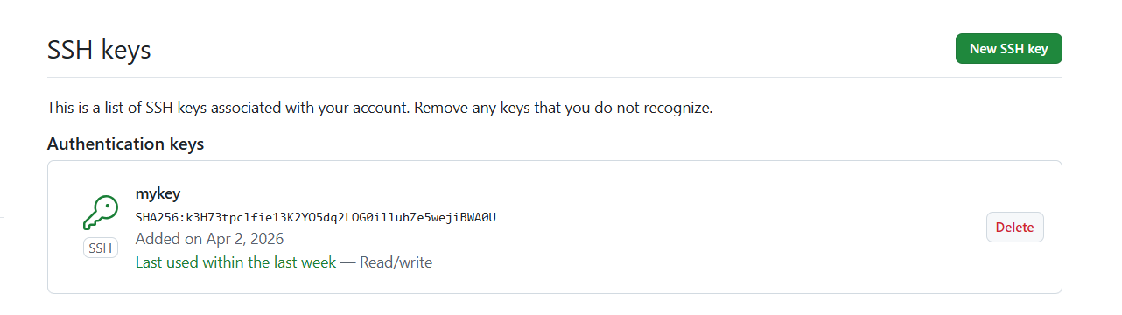
cloning
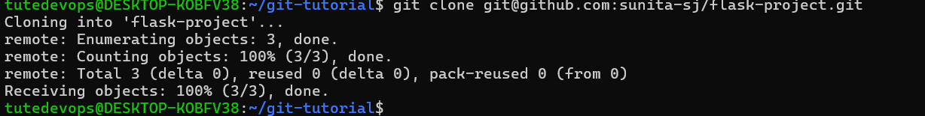

Create a Branch Named After Your Username.
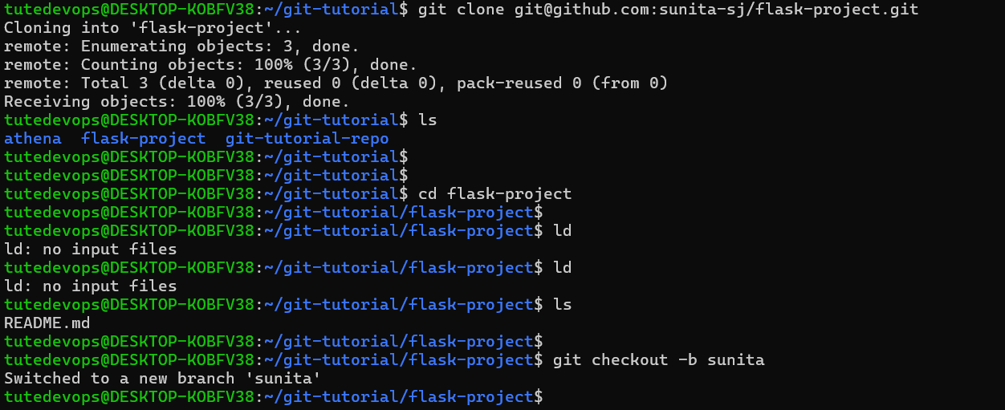
Copied Flask project files into the cloned repo folder.
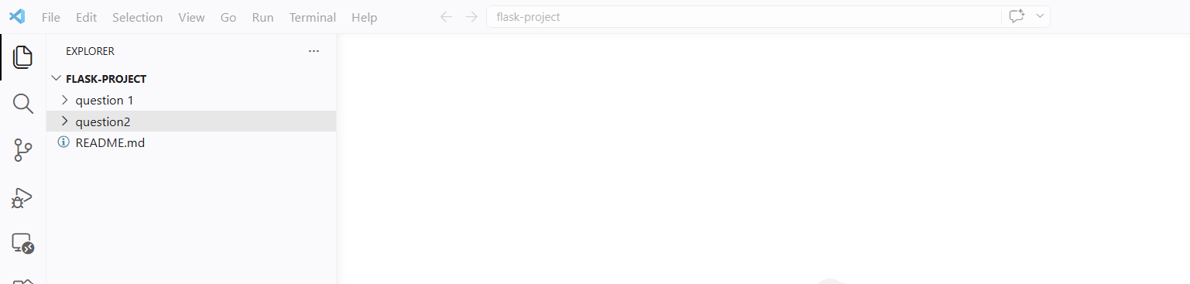

Stage and Commit the Files.
Push Branch “Sunita” to github.
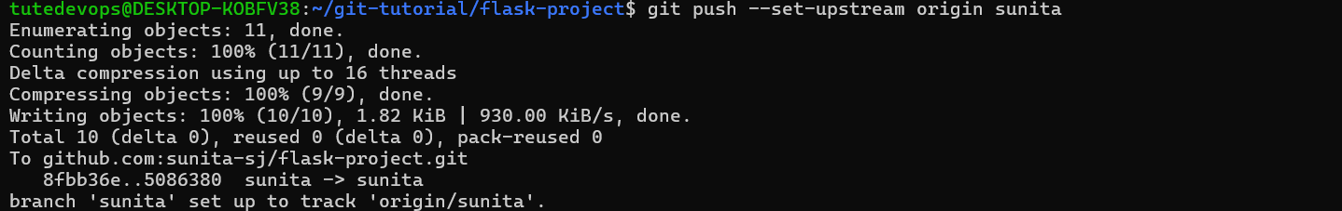
Output from github.
Sunita Branch:
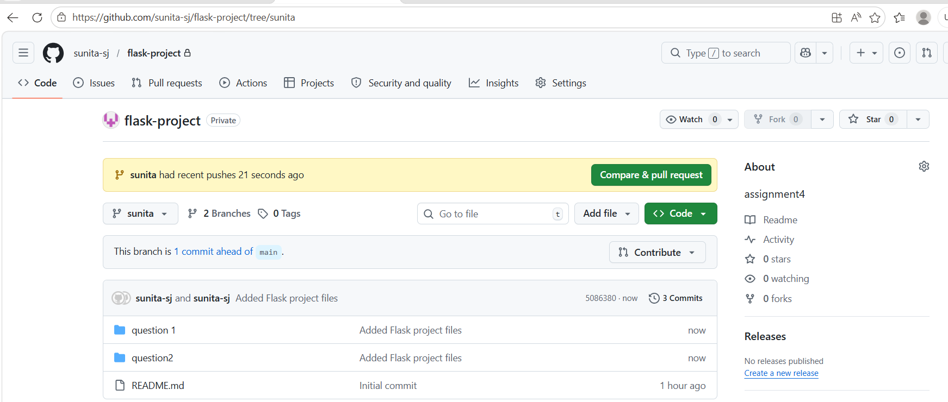

Switch to main branch.
Merge to main branch and push main to github
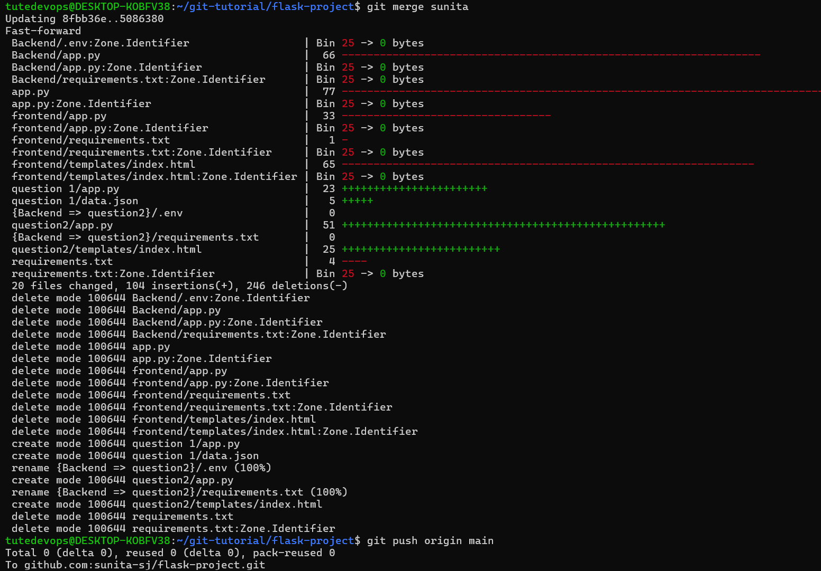

Final output on github.
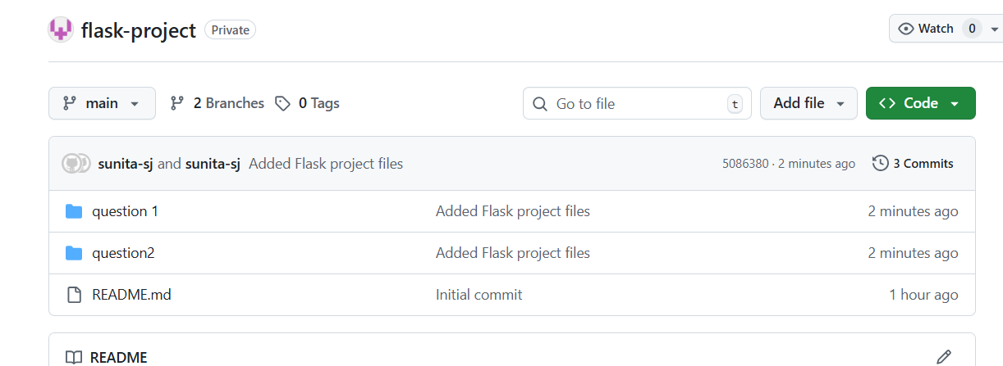

2. Create a new branch named <your_name>_new (e.g., sunita_new).
- Update the content of the JSON file used for the /api route in this branch.
- Merge the <your_name>_new branch into the main branch.
- If there are conflicts during the merge, resolve them by accepting the changes from the <your_name>_new branch.
- Add the resolved changes to the staging area, commit them, and push the updates to the remote repository.
New branch created:
Updated Json file:
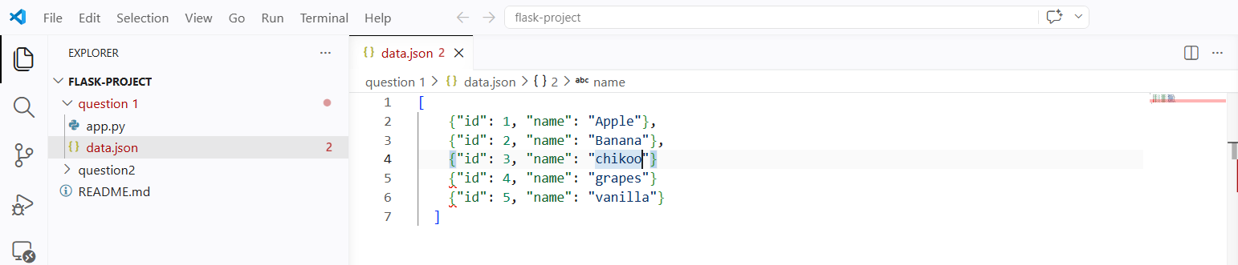

Stage and commit.

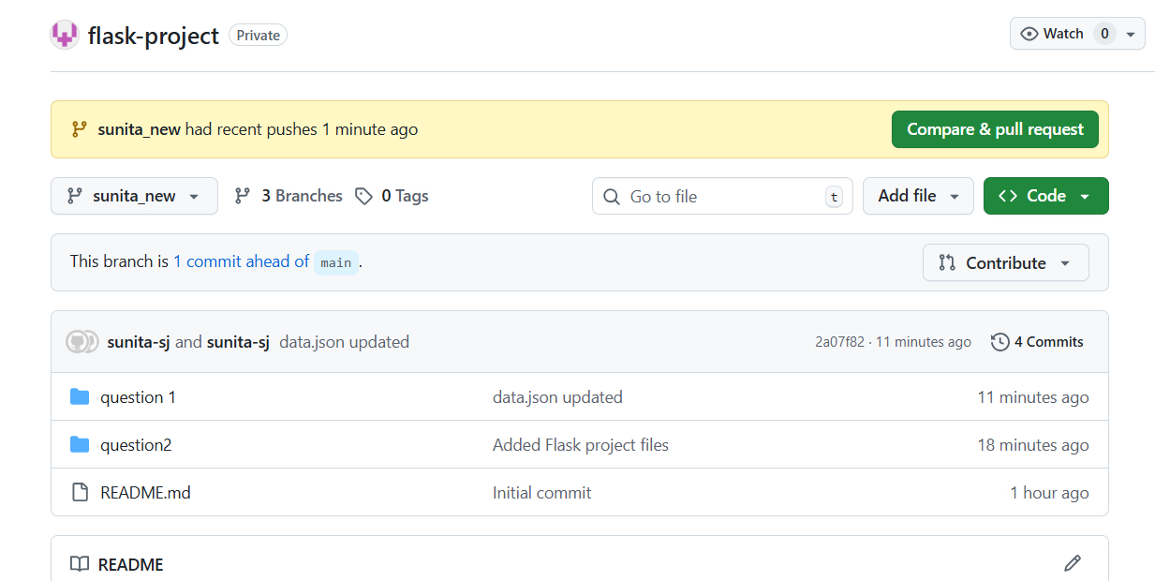

Merge new branch into main branch.
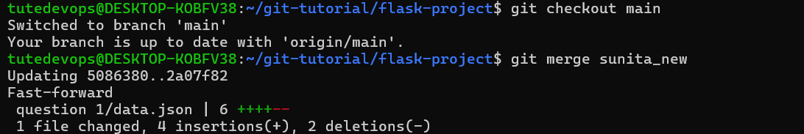

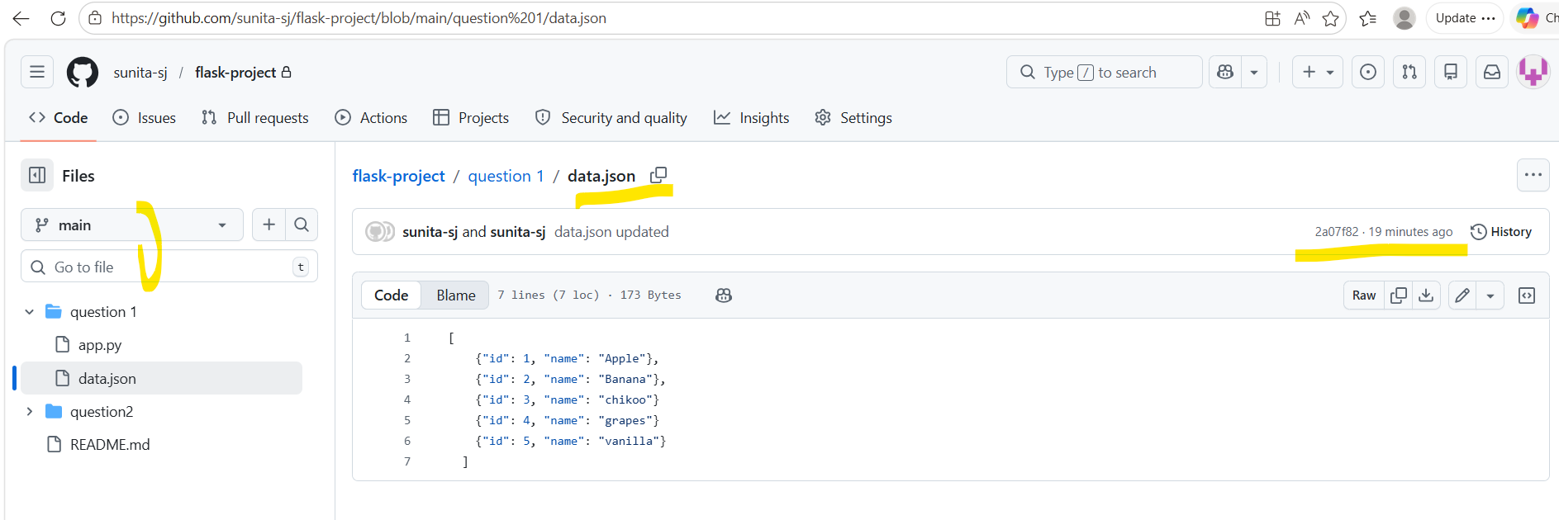

Trying to create conflict scenario. Updated few lines in branch “Sunita_new” and pushed in git hub

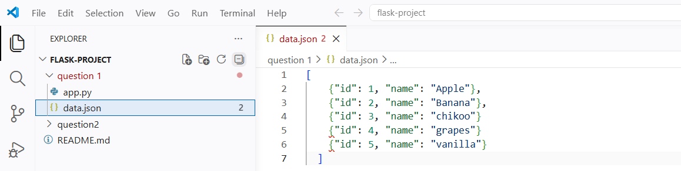

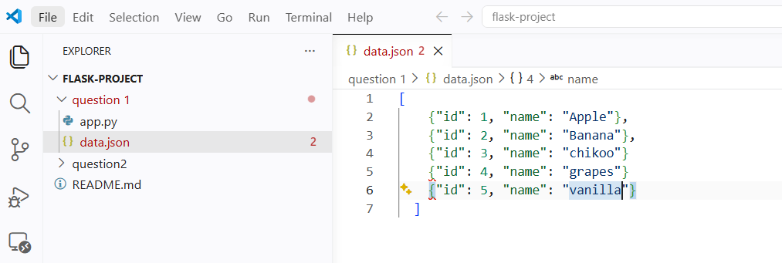

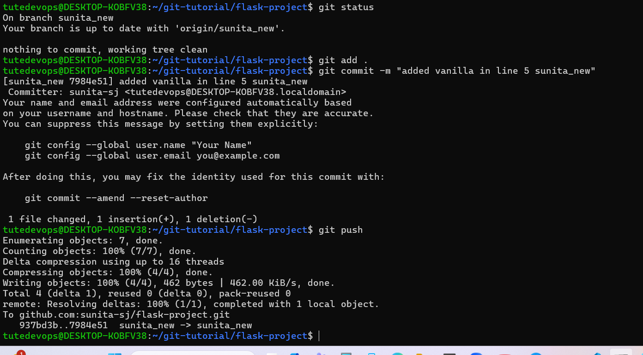

Created pull request from github to merge main < Sunita_new,which created conflict scenrio
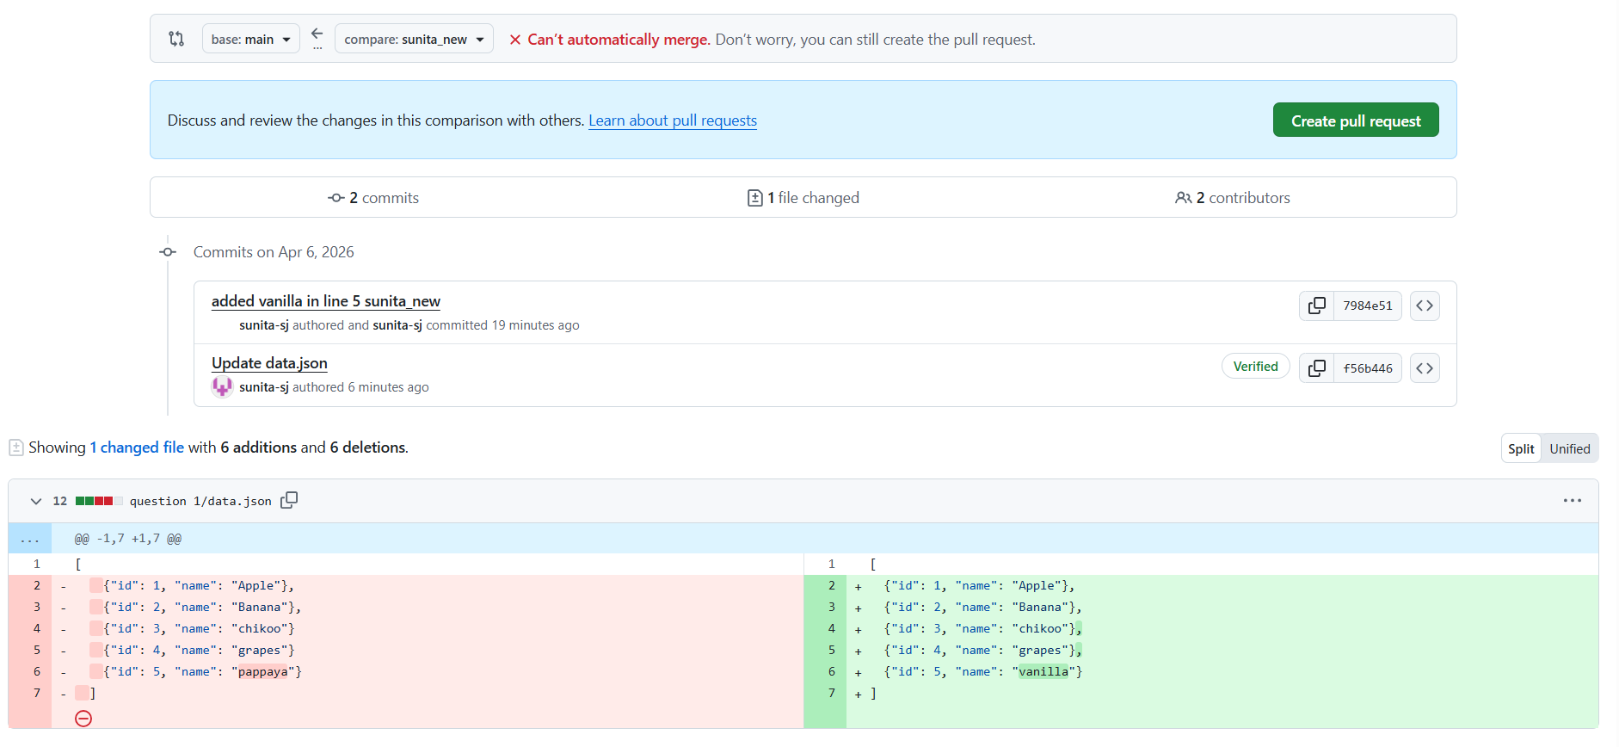
CONFLICT SCREEN
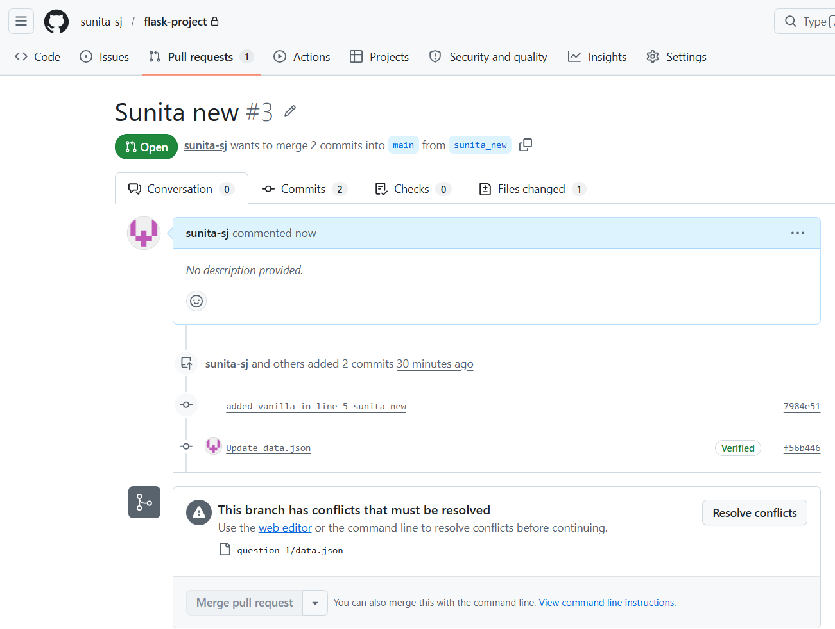

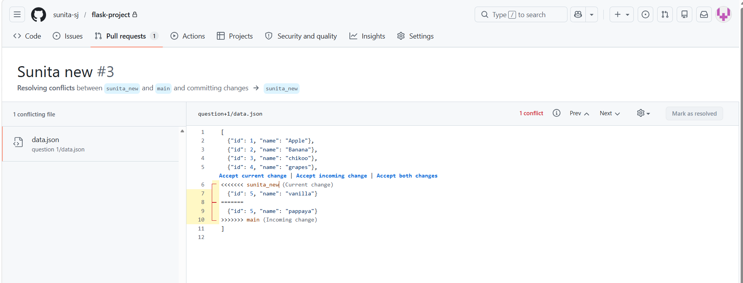
COMMIT merge.
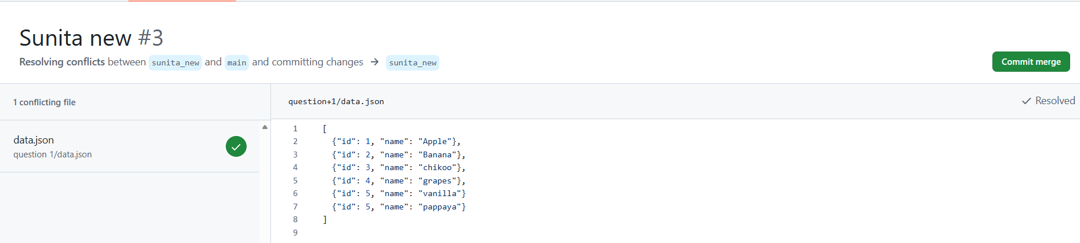

Final data.json on main branch
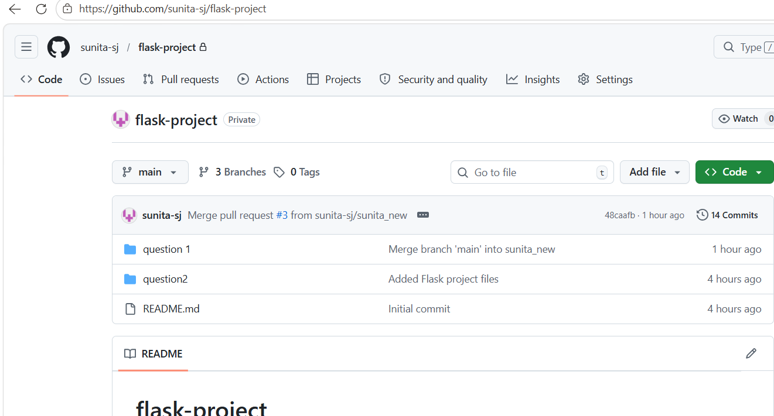

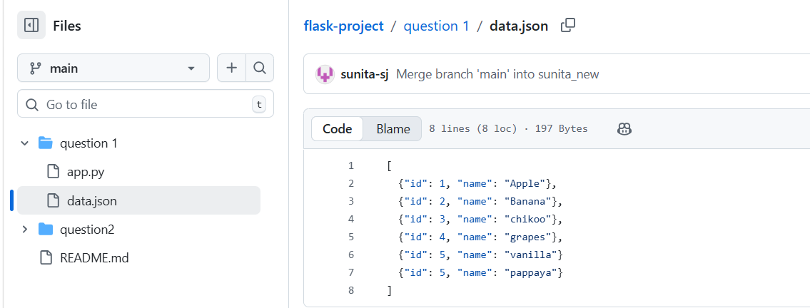
3.

3. Branch Creation:
- Create two branches: master_1 and master_2 from the main branch.
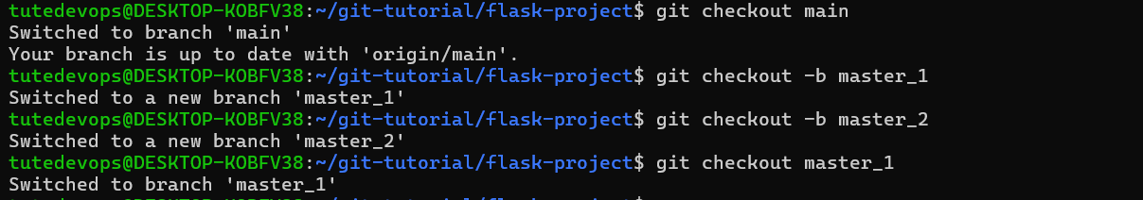

- Feature Development in master_1:
- In the master_1 branch, create a To-Do Page in the frontend.
  - The page should contain a form with the following fields:
    - Item Name
    - Item Description

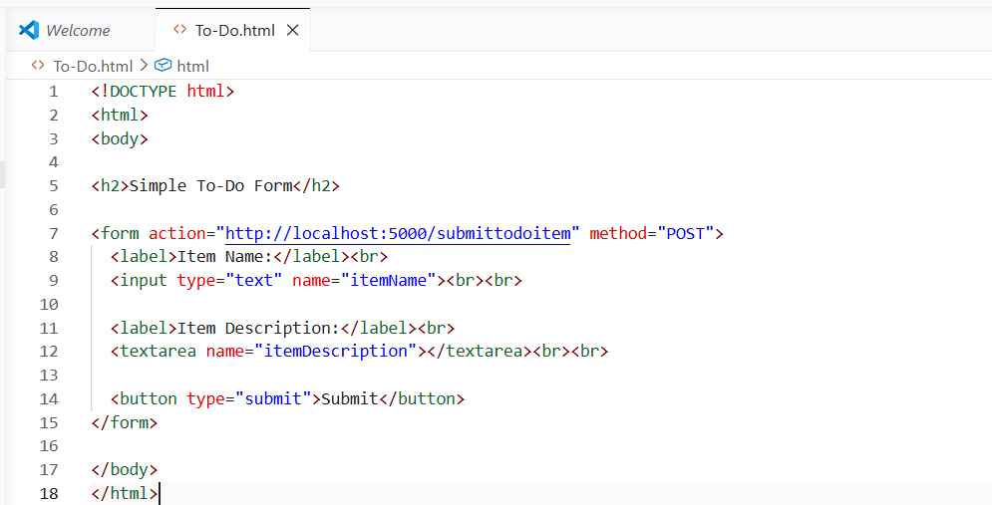

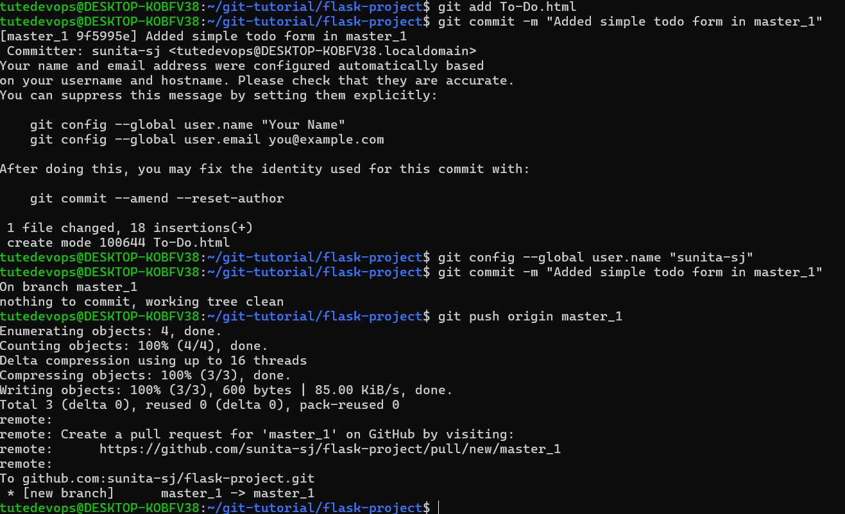
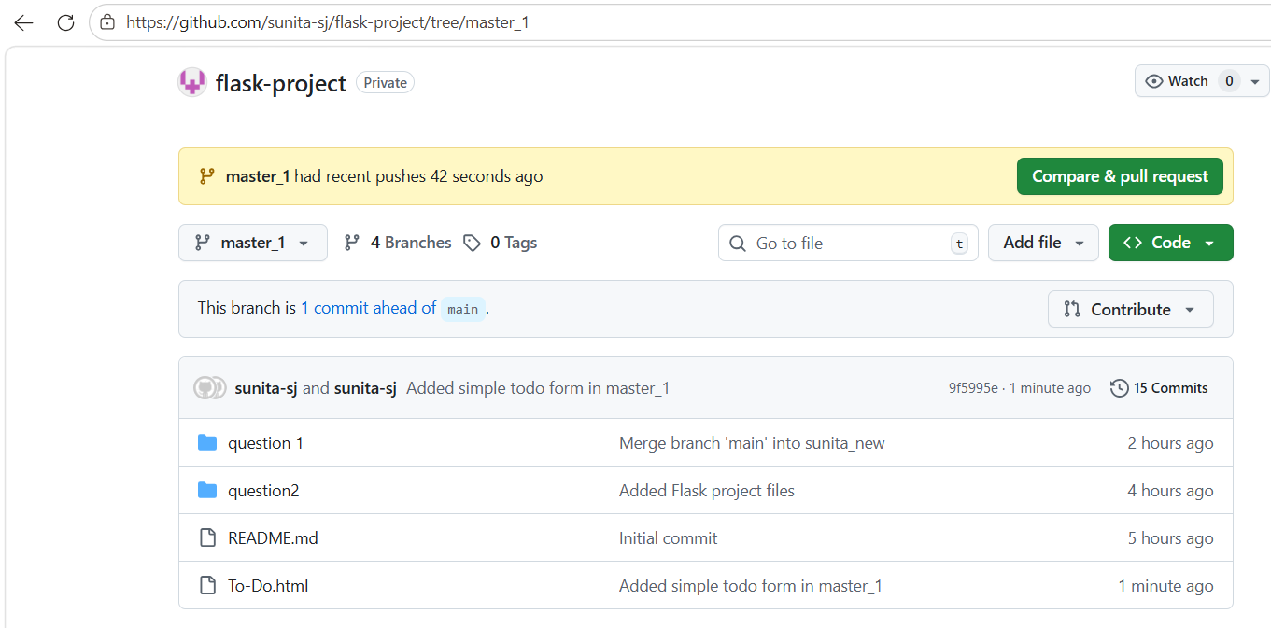

- Backend API in master_2:
App.py created.
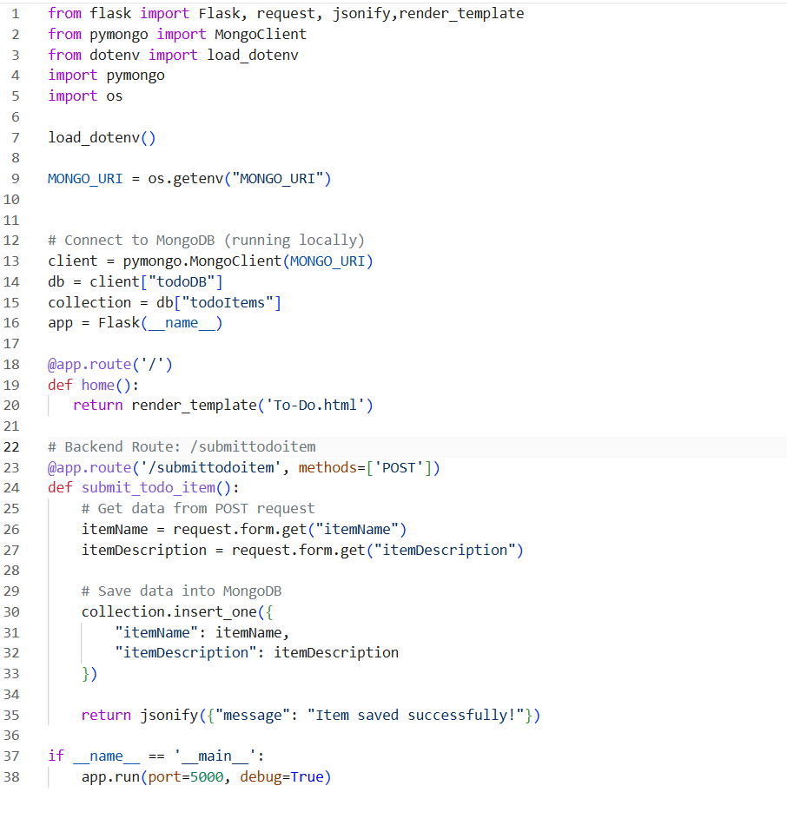
- In the master_2 branch, create a backend route named /submittodoitem.
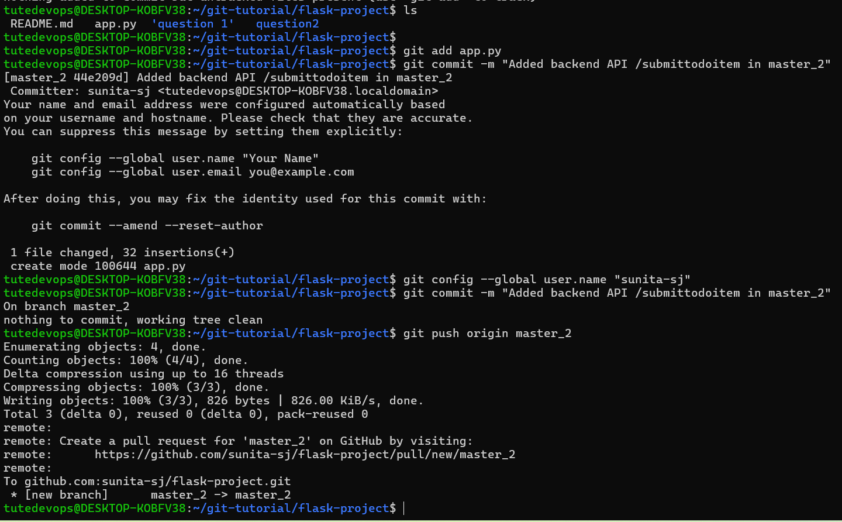
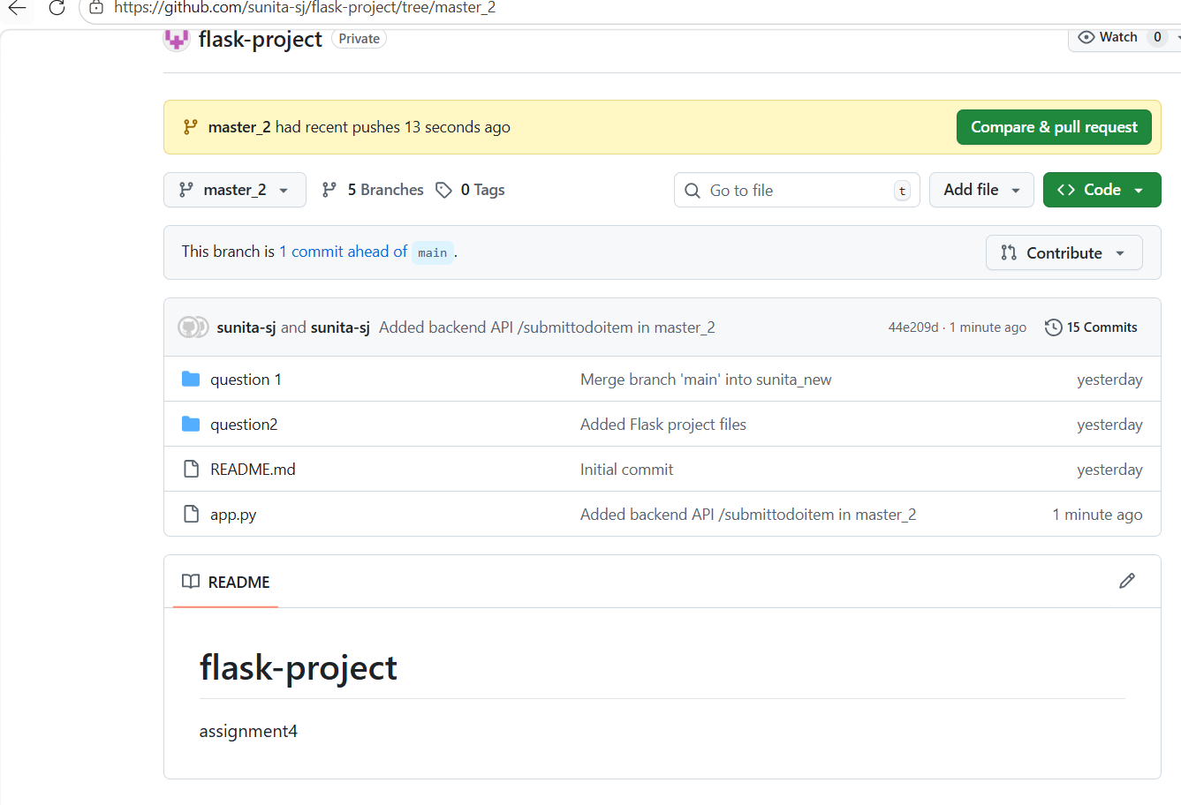

- This route will:
  - Accept itemName and itemDescription via a POST request.
  - Store these details in a MongoDB database.
- Merging Changes:
Merge the changes from both master_1 and master_2 into the main branch.

Merge master_1 to main.
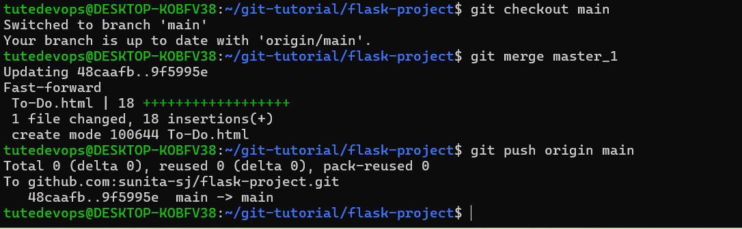

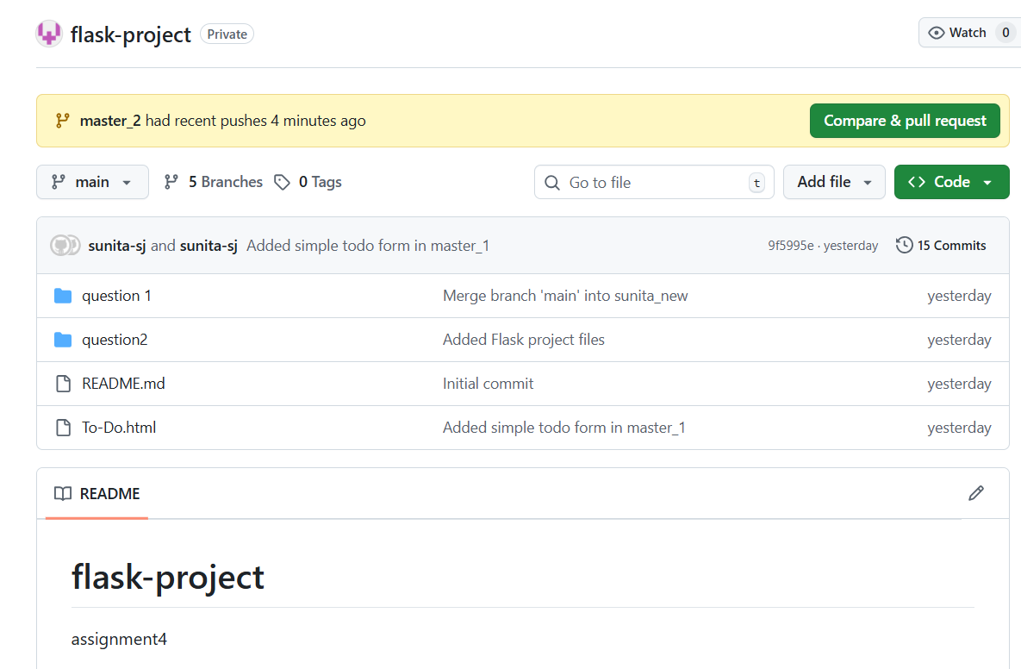

Merge master_2 into main
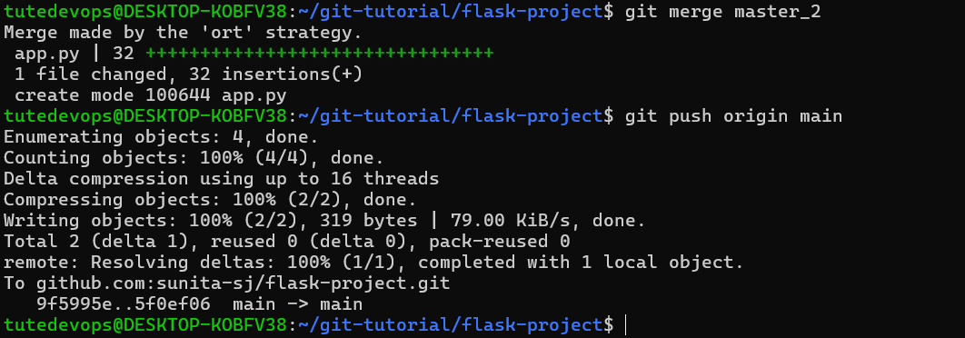

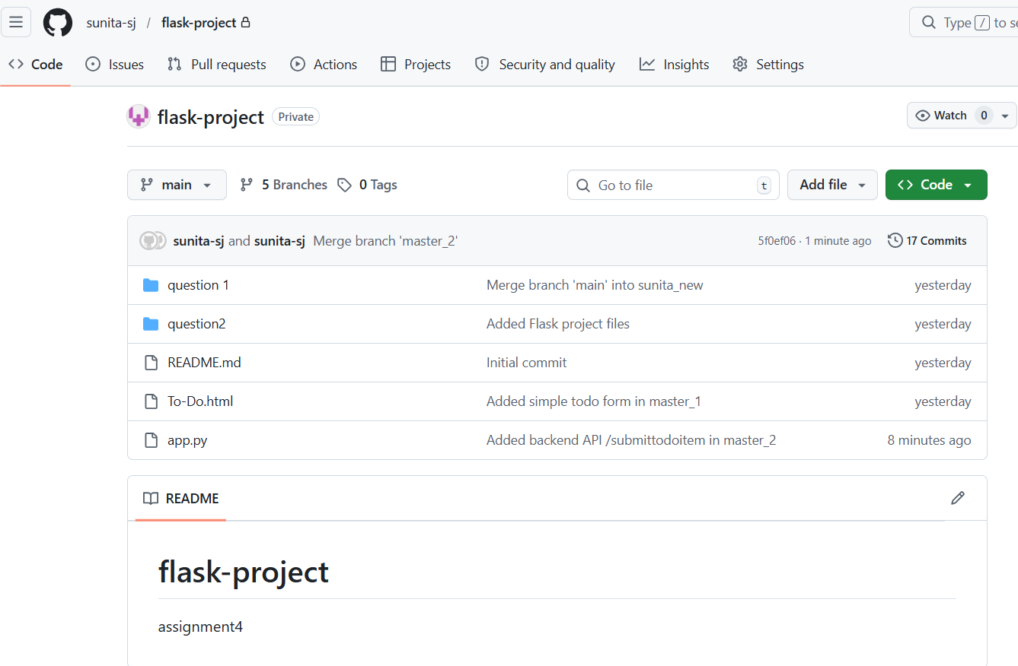

Enhancing the To-Do Form in master_1:
- In the master_1 branch, add the following fields to the To-Do form:
  - Item ID
  - Item UUID
  - Item Hash
- Committing in Sequence:
- Add and commit each field separately in the following order:
  - First commit: Add Item ID field.
  - Second commit: Add Item UUID field.
  - Third commit: Add Item Hash field.
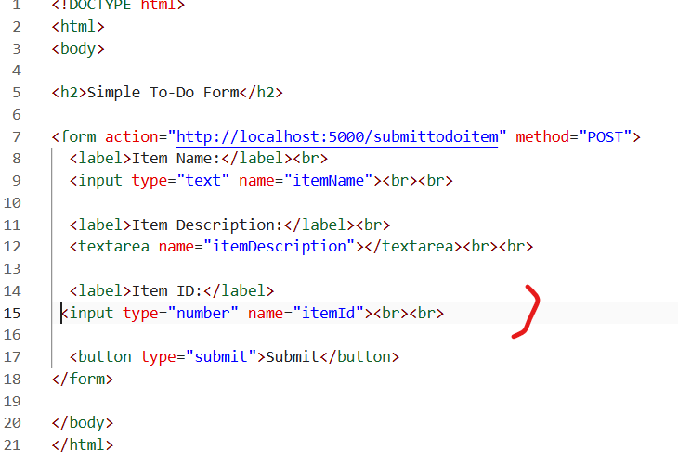
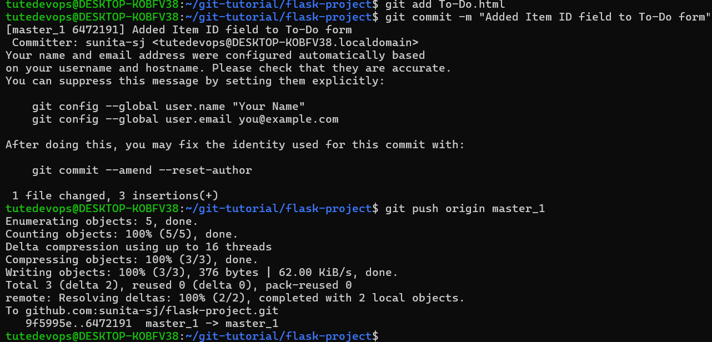
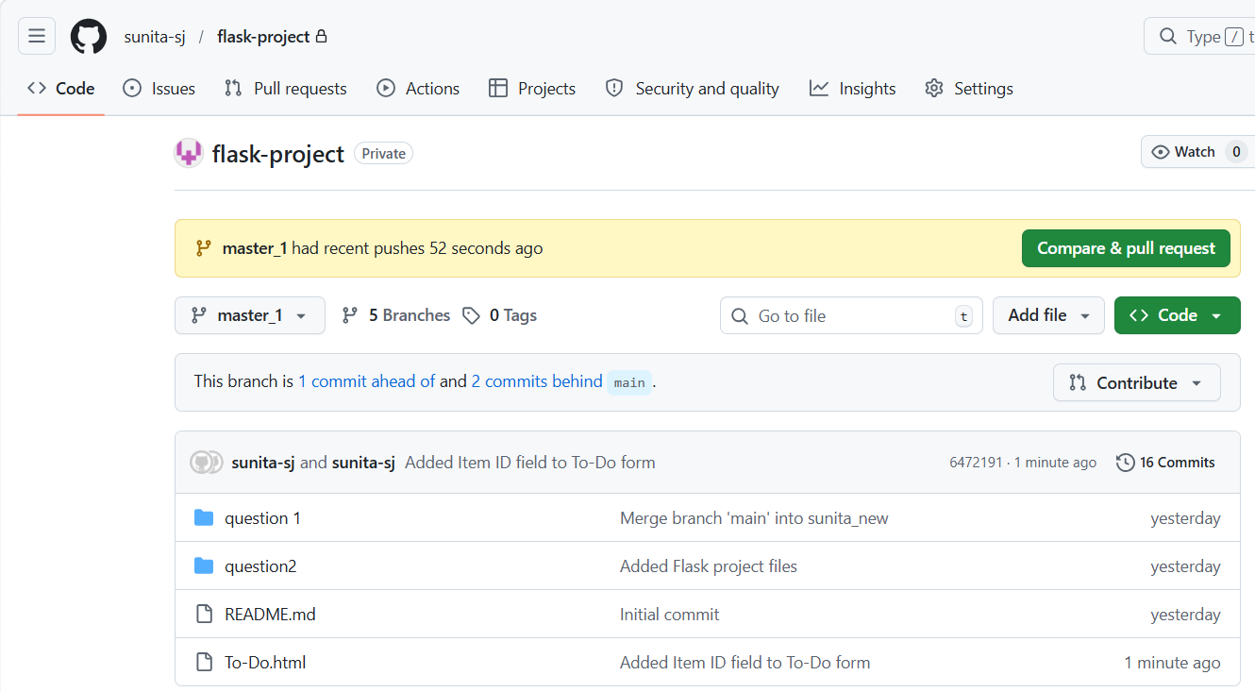

2nd change:
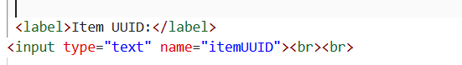
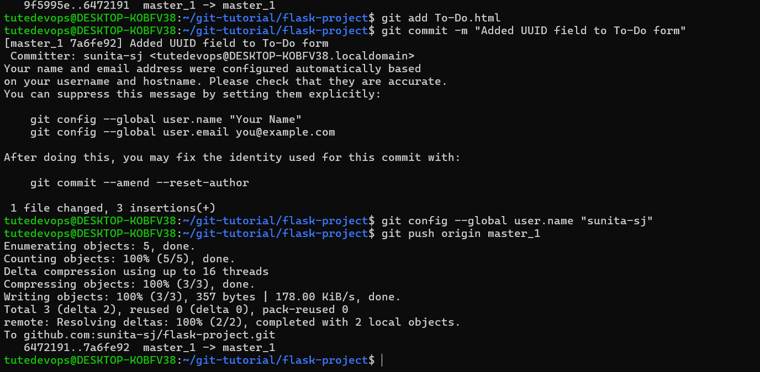
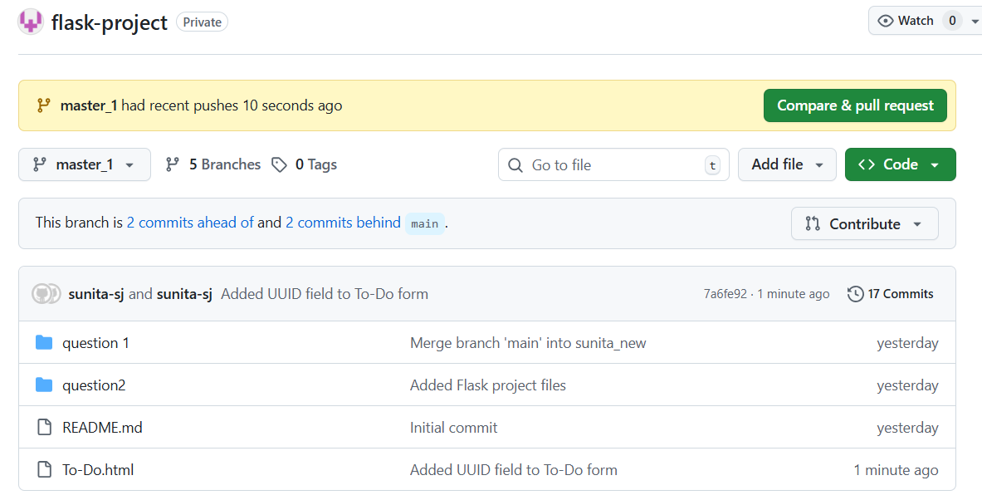

3rd commit:
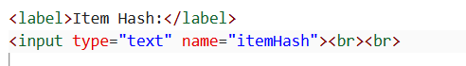

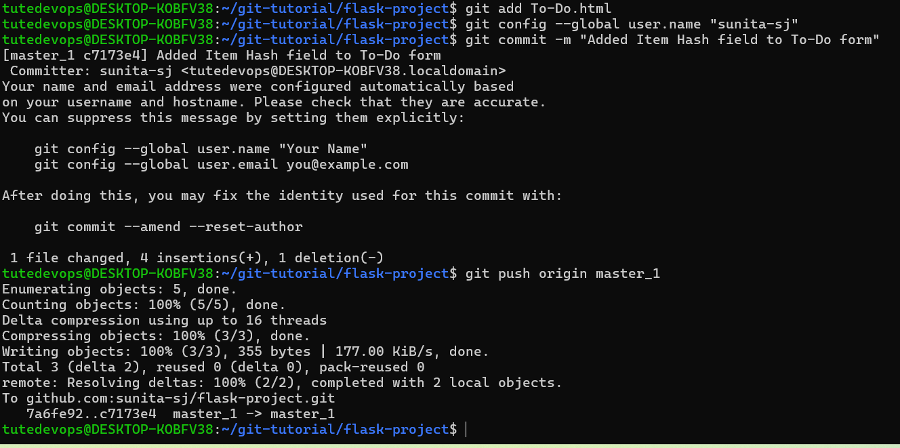
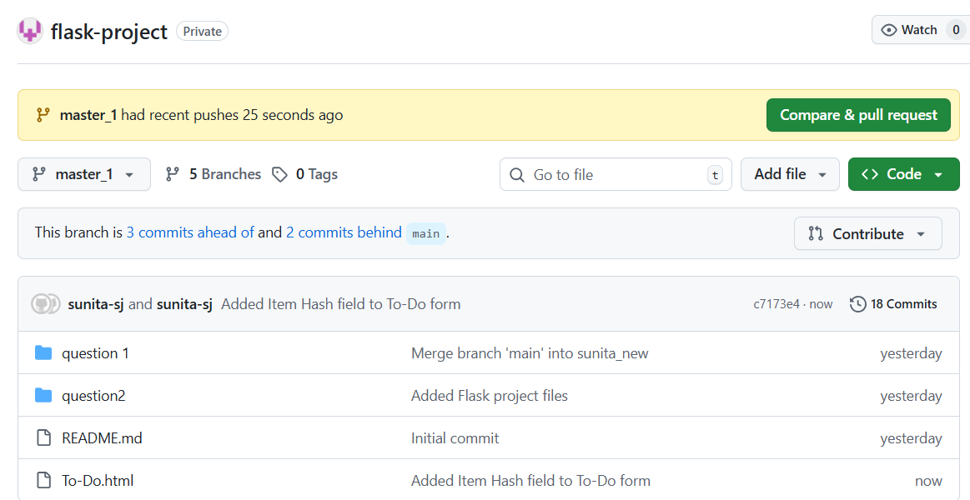
- Merging to main:
- Merge the master_1 branch into the main branch.
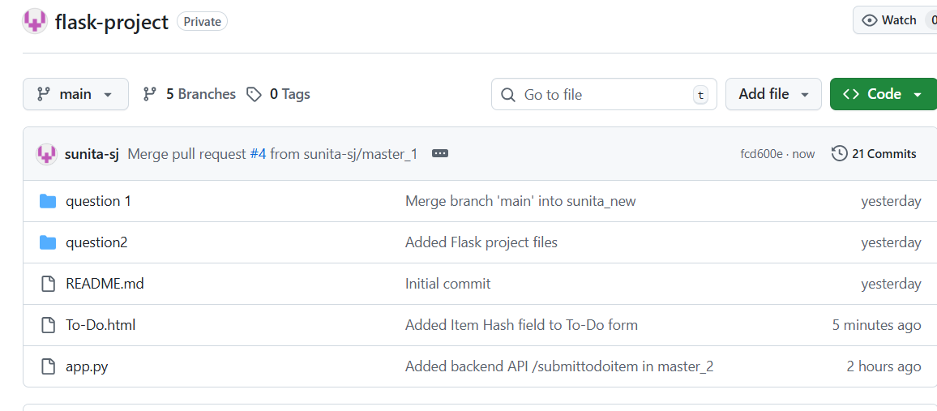
- Git Reset and Commit Deletion:
- In the main branch, use Git Reset to roll back to the commit where only the Item ID field was added.
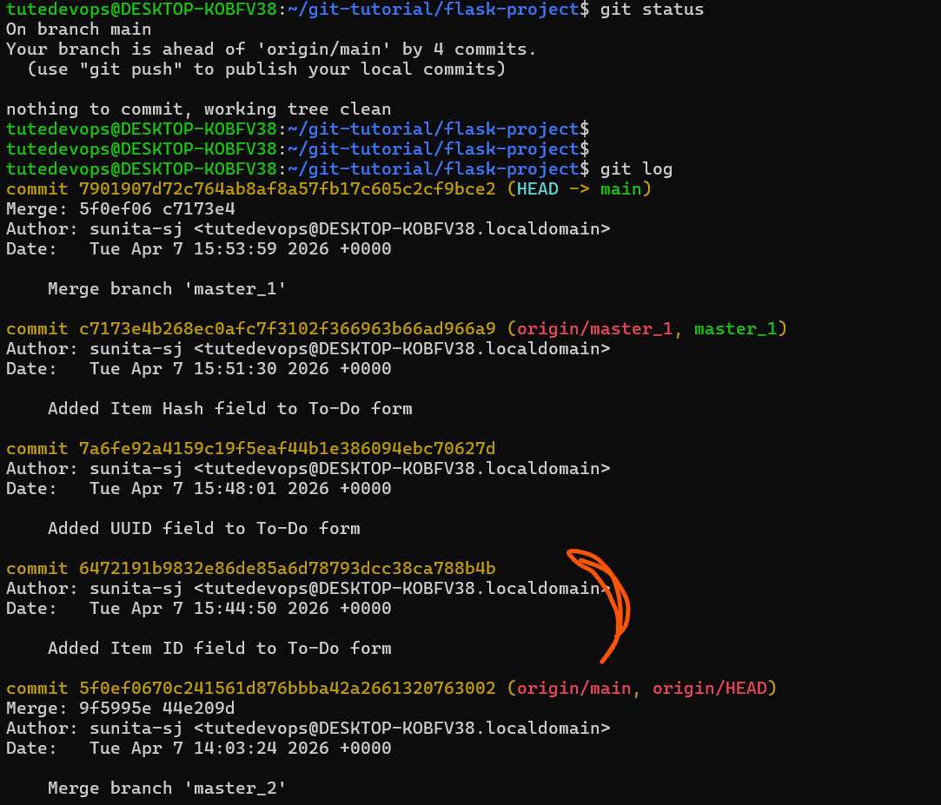
- Use git reset --soft to ensure changes remain staged.
- Re-commit this state to the main branch.
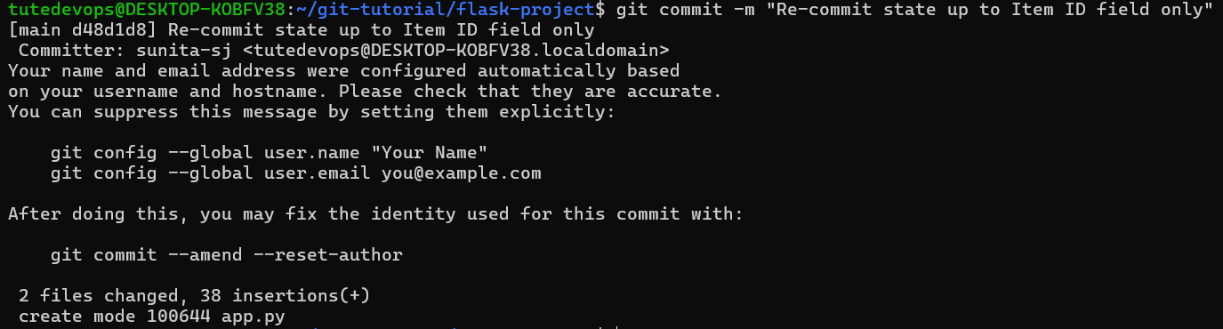
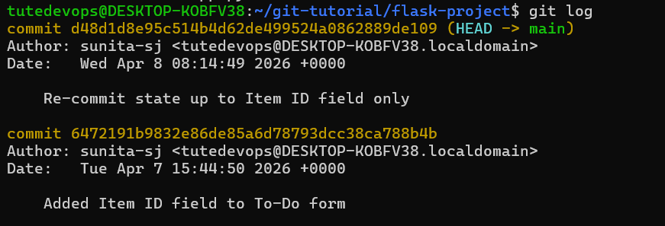
- Merge this updated state to the main branch:
Since history changed, you must force push.
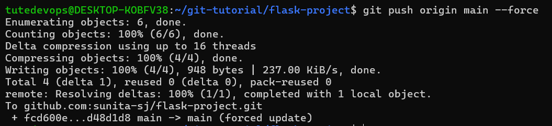
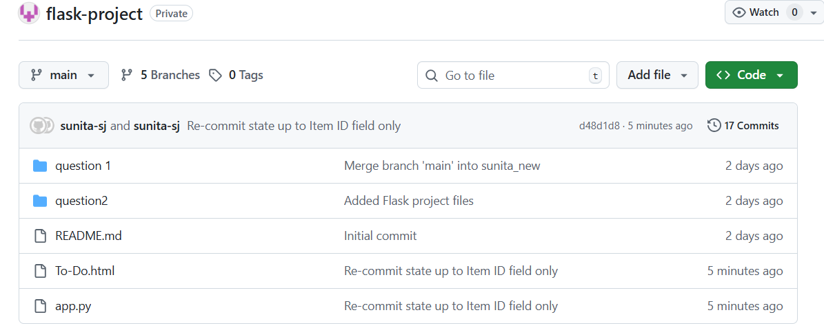
- Rebasing Changes:
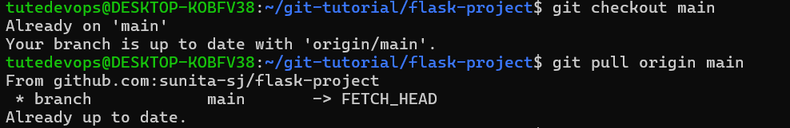
- Rebase the updated changes in the main branch to the master_1 branch.
Clarification:
  - During rebasing, preserve individual commits to maintain the commit history for each change (i.e., do not squash commits
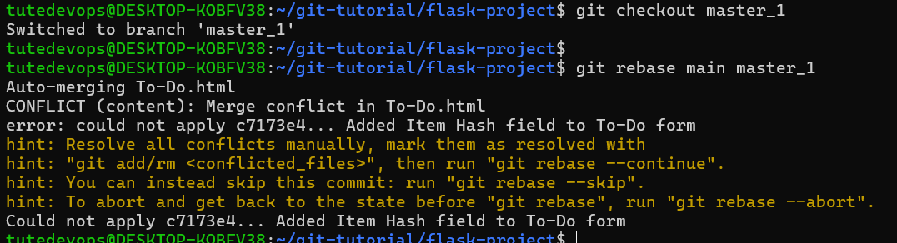

  - Use git rebase main master_1 to integrate changes from the main branch back into the master_1 branch.
